Evaluation Projects through Vienna principles

# WHat is Vienna Principles?

There are twelve Principles of Scholarly Communication Scholarly that represent the cornerstones of the future scholarly communication system. They are designed to provide a coherent frame of reference for the debate on how to improve the current system. With this document, we are hoping to inspire a widespread discussion towards a shared vision for scholarly communication in   the 21st century[(Kraker et al. 2016)](https://www.zotero.org/google-docs/?29WqkH)

# Methodology analysis

The analysis was made individually and shared the insights as a group. The score applied was from 1 to 5 (1-5 low-to-high score). The framework evaluation used was the 10 of the Vienna Open Science Principles. Also, there were added few comments about mprovements to each project.

# Results

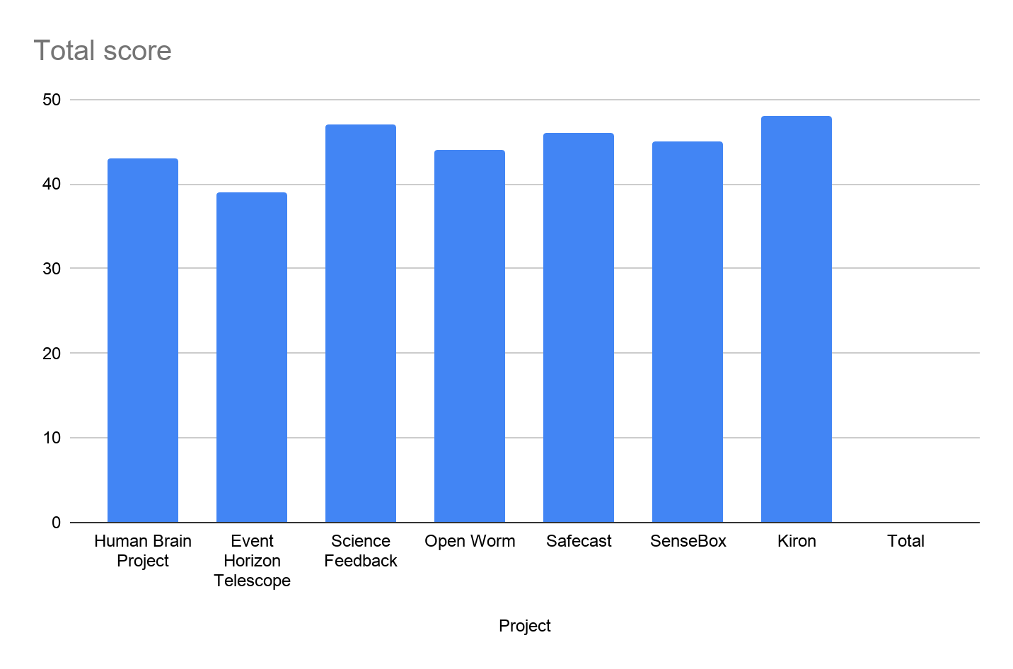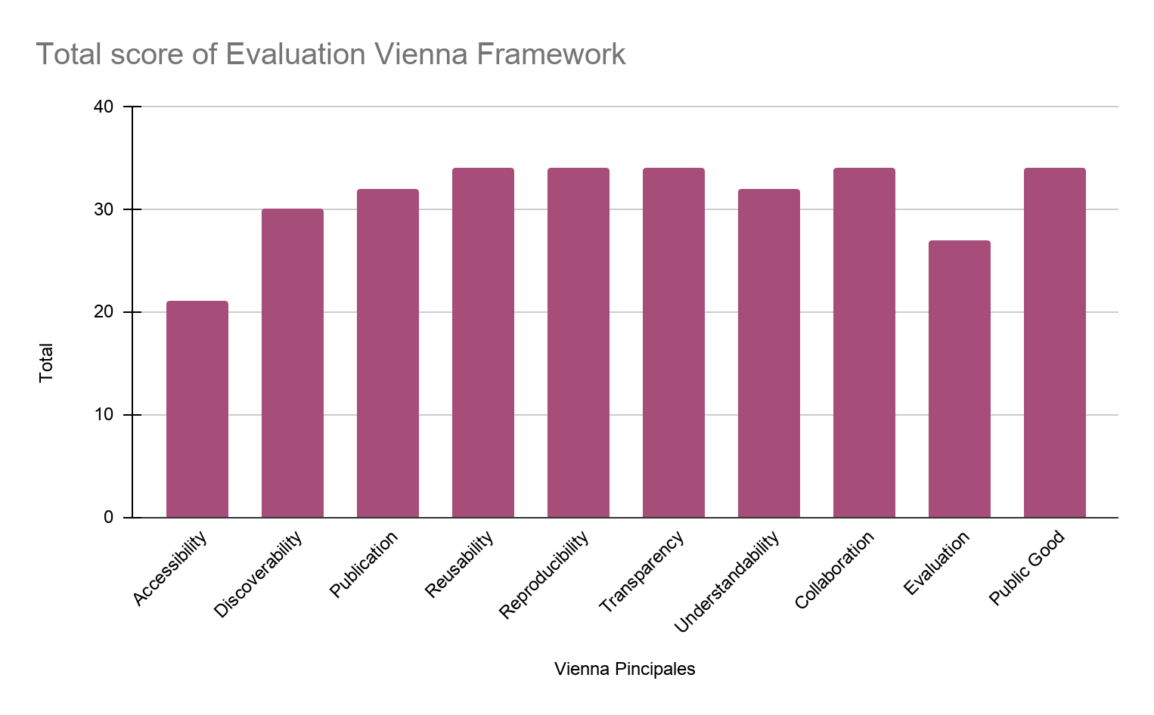

## Analysis Results

4.1. Human Brain Project

**Research infrastructure to help advance neuroscience, medicine, and computing**,

The accessibility is limited because it can be read in one language is english, it's made for a student community, and has 1.227 Publications. They have a lot of events. Not much improvement, it's a really big project with a lot of small projects in it divided into 6 groups

## 4.2. SenseBox

**Environmental Testing For All**

The accessibility is limited because it is written in only two languages. It can be discovered with easy access for students, once an adult sets up the sensor for them, it has the ability to share data freely on websites and other forums. Seems like relatively simple technology and has the ability to download/upload the data for future use with the same technology for all participants, just 3 different levels. Sharing of information/technical issues on forum helps people

Note:

Tasks I couldn't do it:

1. Create a content index
2. Give autoformat of the numbers of the titles